|  |  |
| --- | --- |
| Logo_FPT_University_doc | **MINISTRY OF EDUCATION AND TRAINING** |

**FPT UNIVERSITY**

**CAPSTONE PROJECT DOCUMENT**

pLED

**Report #1 – Project Introduction**

|  |  |
| --- | --- |
| **FAST5** | |
| **Group Member** | Nguyễn Thanh Tùng – SE01960 |
| Đinh Quang Hải – SE02354 |
| Đỗ Văn Ban - 01870 |
| Đinh Xuân Bách - 60343 |
| Nguyễn Thế Long – SE02241 |
| **Supervisor** | Mr. Phan Duy Hùng |
| **Ext. Supervisor** |  |
| **Project Code** | pLED |

- Hanoi, 01/2014 -

Table of Contents

[1 INTRODUCTION 3](#_Toc377723647)

[1.1 Purpose 3](#_Toc377723648)

[1.2 Acronyms and Definitions 3](#_Toc377723649)

[2 BACKGROUND 3](#_Toc377723650)

[3 LITERATURE REVIEW 3](#_Toc377723651)

[4 PROPOSAL 4](#_Toc377723652)

[4.1 The idea 4](#_Toc377723653)

[4.2 Objectives 5](#_Toc377723654)

[4.3 Brief description about system 5](#_Toc377723655)

[4.4 System features 5](#_Toc377723656)

[5 BENEFIT FROM PROJECT 5](#_Toc377723657)

[5.1 For Organization 5](#_Toc377723658)

[5.2 For our group 6](#_Toc377723659)

[5.3 For Community 6](#_Toc377723660)

[6 CRITICAL ASSUMPTION AND CONSTRAINTS 6](#_Toc377723661)

[7 POTENTIAL RISKS 6](#_Toc377723662)

[8 REFERENCES 7](#_Toc377723663)

# INTRODUCTION

## Purpose

The purpose of this document is to introduce the development team and the idea of group’s Capstone Project, from its initial idea to its features, existing methods and solutions. It contains our finding about the propeller display led, its concept, base theory, hardware, and software requirement.

## Acronyms and Definitions

|  |  |  |
| --- | --- | --- |
| Acronym & Abbreviation | Definition | Note |
| LED | Light emitting diodes |  |
| POV | Persistence of Vision |  |
| pLED | Project code, abbrevation for Propeller display Led |  |
| RPM | Rounds per minute |  |
| RF | Radio Frequency |  |
|  |  |  |

Table 1-1: Definitions and Acronyms

# BACKGROUND

Our group includes of 5 members, all studying in Software Engineering – Embedded System, FPT University. Having a common interest in the idea of the project, knowing each other’s skills and characters, we had assembled to working together for the Capstone Project. We understand that this is our chance to demonstrate our knowledge and skills acquired while studying at FPT University.

After considered several ideas for our project, base on our capability and preferences, we decided to choose the led propeller clock idea.

# LITERATURE REVIEW

In this document, we want to introduce the idea of our project, the similar products, the existing methods and explanations. Then we propose our product’s features, enhancement and limitation.

# PROPOSAL

## The idea

The propeller clock, also known as “persistence of vision” display is the idea utilized a mechanically scanned display usually consisting of a row of LEDs. The LEDs are not illuminated constantly. The LEDs turn on and off at precise intervals, one after another, extremely rapidly while being rotated at several thousand RPM. Due to the slow response of the human eye an effect known as Persistence of Vision gives the illusion of a static stable display.

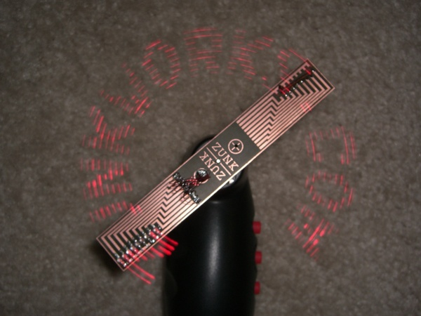

*Figure 1: a propeller display led.*

## Objectives

Create an amazing electronic product – a multi color propeller clock that use POV for optical illusion. The propeller should be able to display at every angle from 00 to 3600 in 10 increment. RF module should be used as remote to change the display mode on propeller.

## Brief description about system

The system based on "Persistence of vision" phenomenon of human's image memory, make use of the LED's quick responsiveness to create a amazing illusion: a rotating motion of a straight electronic board create a colorful round clock/image frame.

The components include: main clock, 3v battery cell, 12v adapter, radio remote.

System's functions will be provide "as-is", cannot be change without developer's kit.

## System features

* Display clock in real-time.
* Two to three display option:

+ Digital clock

+ Analog clock

+ Static image or text

* User can change display mode by remote control.

# BENEFIT FROM PROJECT

## For Organization

* Develop product for Embedded System, pLED is the device support demo lecture in the lab room.
* Save data information of project and production for searching Capstone Project.

## For our group

* Increase the skills of teamwork
* Management project: scope, time, cost
* Research and learning new technology (radio frequency , microchip programing …)
* Understand analyses, design, and architecture circuit of embedded system.
* Design physical, electro-mechanical equipment

## For Community

Provide clear and legible documents for another students or any one who interested and new in electronics to build a propeller clock on their own. Create a community inside the university or may be large for everyone to share, exchange experience and passion in electronics.

# CRITICAL ASSUMPTION AND CONSTRAINTS

* The "main clock" include the electrical board, motor and firmware.
* "Development kit" include testing board, board design software, emulation software, firmware IDE.
* Electrical board printing time is 2 weeks.
* The document delivery date is 15/4, product delivery is 25/4.
* Development kit is always available for replace.

# POTENTIAL RISKS

* There might be problems with hardware design due to the lack of knowledge in this matter.
* Time delay for waiting print board and order electronic component
* Working in group and manager skill also are the problem.
* Electronic component can be broken or overheated, resulting in failure of the system.

# REFERENCES

[1] Alessandro, Propeller Clock, last modified on 31 August 2007, <http://wiki.4hv.org/index.php/Propeller_clock>

[2] Persistence of vision, last modified on 17 December 2013, <http://en.wikipedia.org/wiki/Persistence_of_vision>

[3] PCP Capstone Project, Hanoi, December 2012, FPT University